**SAN Agriculture Workgroup Meeting**

**Virtual Meeting Agenda**

**November 6, 2024**

10:00 - 11:30 am

**Online**:

[Join Zoom Meeting](https://us06web.zoom.us/j/82356171545?pwd=2DY43IOcivbJQaPEtR4YbrcW2GaTtE.1)

Meeting ID: 823 5617 1545

Passcode: 557158

**Meeting Objectives:**

* Discuss agricultural conservation/restoration projects as they relate to the 2024 work plan
* Updates on Projects and Programs
* Review next steps and action items

1. **Welcome & Introductions** (10:30-10:40) - All
2. **SAN Updates** (10:40-11:10) – Meghan & All
   1. SAN Project Wish List – please email Meghan with details on priority projects for SAN
   2. [2024 Work Plan](https://docs.google.com/spreadsheets/d/1JU_aemqyVBLAGKdpPncI7EPHYydmZ1kPOKHvGDuibZw/edit?usp=sharing)

***Group Discussion - Action 3c:*** Expand upon localized momentum for agricultural conservation and restoration by including new partners and geographies in the watershed

1. What have you been working on recently that touches this component of the work plan?
2. From the news- [French & Pickering Creeks Conservation Trust Partners With Raymond & Kathleen Nester To Permanently Preserve 24-Acre Farm In Chester County](https://paenvironmentdaily.blogspot.com/2024/10/french-pickering-creeks-conservation.html)
3. **Partner Updates** – Grants, funding programs, projects (11:10 – 11:40) - All
   1. Conservation Easements – Kim & Larry
   2. USDA NRCS Program Updates- Nick
      1. Environmental Quality Incentive Program (EQIP)
      2. National Water Quality Initiative (NWQI)
      3. Conservation Stewardship Program (CSP)
      4. Regional Conservation Partnership Program (RCPP)
      5. Conservation Reserve Enhancement Program (CREP)
      6. Cover Crop Funds
      7. Emergency Watershed Program (EWP)
   3. ACAP - Josh, Kim & Nick
   4. National Fish & Wildlife Foundation (NFWF) – BCCD & All
      1. Delaware Watershed Conservation Fund (DWCF) – basin-wide
         1. BerksCCD Cold Run Habitat Restoration and Agricultural BMP (& SRRF)
         2. Grube Farm
   5. Schuylkill River Restoration Fund - Larry, Brendan & All
      1. Berks Nature
         1. Masemore
         2. Bitler
      2. BerksCCD
         1. Weinsteiger
      3. PVTU
         1. Longacre Farm
      4. LCCD
         1. Lynnacres
         2. Last Chance Angus
   6. Growing Greener Projects - BCCD
      1. Riparian Buffer Implementation in Berks Co
      2. Cacoosing Floodplain Assessment
   7. Urban Ag Programs - BCCD & All
   8. Other Ag Funding Programs and Projects - All
4. Education & Outreach Project Updates – Workshops, events (11:40-11:50) – All
   1. Ag & Natural Resources Job Fair - November 14 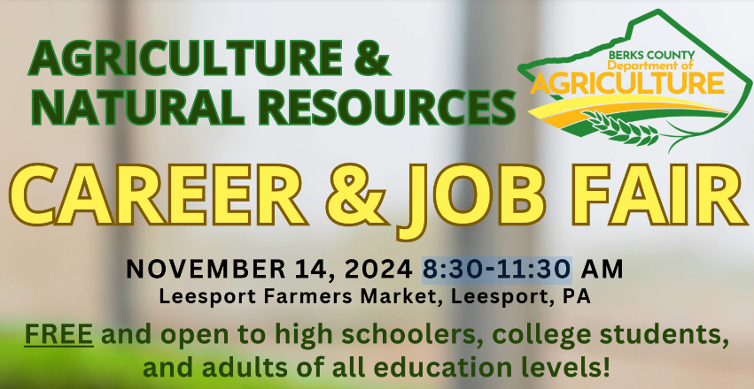
5. Other (11:50 - 11:55) - All
   1. News
      1. [French & Pickering Creeks Conservation Trust Partners With Raymond & Kathleen Nester To Permanently Preserve 24-Acre Farm In Chester County](https://paenvironmentdaily.blogspot.com/2024/10/french-pickering-creeks-conservation.html)
      2. [Conservation Innovation Fund Announces 2nd Round Of Farm Enrollment For Climate-Smart Commodities Market Program](https://paenvironmentdaily.blogspot.com/2024/10/conservation-innovation-fund-announces.html)
6. Wrap Up & Next Meeting Dates (11:55 - 12:00)
   1. Next Meeting Dates
      1. 2025
      2. Berks County Fair- July 10th 2025